GANPAT UNIVERSITY

U.V PATEL COLLEGE OF ENGINEERING & TECHNOLOGY

DEPARTMENT OF COMPUTER SCIENCE AND ENGINEERING

B.TECH 1ST SEMESTER SUBJECT

NAME:SANYAMI SHAH

STREAM:BDA

DATE:27/8/14

SUBJECT:ESFP

ASSIGNMENT:1

1. Write a program to print ASCII values of all backslash characters and white space on screen in following format :

The ASCII value of ‘\t’ is : 9

(Hint : you can verify your ASCII values with the help of a table for ASCII values from text book)

2. Explain different data types available in C.

3. Explain about C Tokens in brief.

4. Explain about backslash characters in C.

**ANS-1**

**#include<stdio.h>**

**#include<conio.h>**

**void main()**

**{**

**char a;**

**clrscr();**

**a='\a';**

**printf("\nthe ascii value of'\\a' is:%d",a);**

**a='\b';**

**printf("\nthe ascii value of '\\b' is:%d",a);**

**a='\f';**

**printf("\nthe ascii value of '\\f' is:%d",a);**

**a='\n';**

**printf("\nthe ascii value of '\\n' is:%d",a);**

**a='\r';**

**printf("\nthe ascii value of '\\r' is:%d",a);**

**a='\t';**

**printf("\nthe ascii value of '\\t' is:%d",a);**

**a='\v';**

**printf("\nthe ascii value of '\\v' is:%d",a);**

**a='\?';**

**printf("\nthe ascii value of '\\?' is:%d",a);**

**a='\\';**

**printf("\nthe ascii value of '\\\' is:%d",a);**

**getch();**

**}**

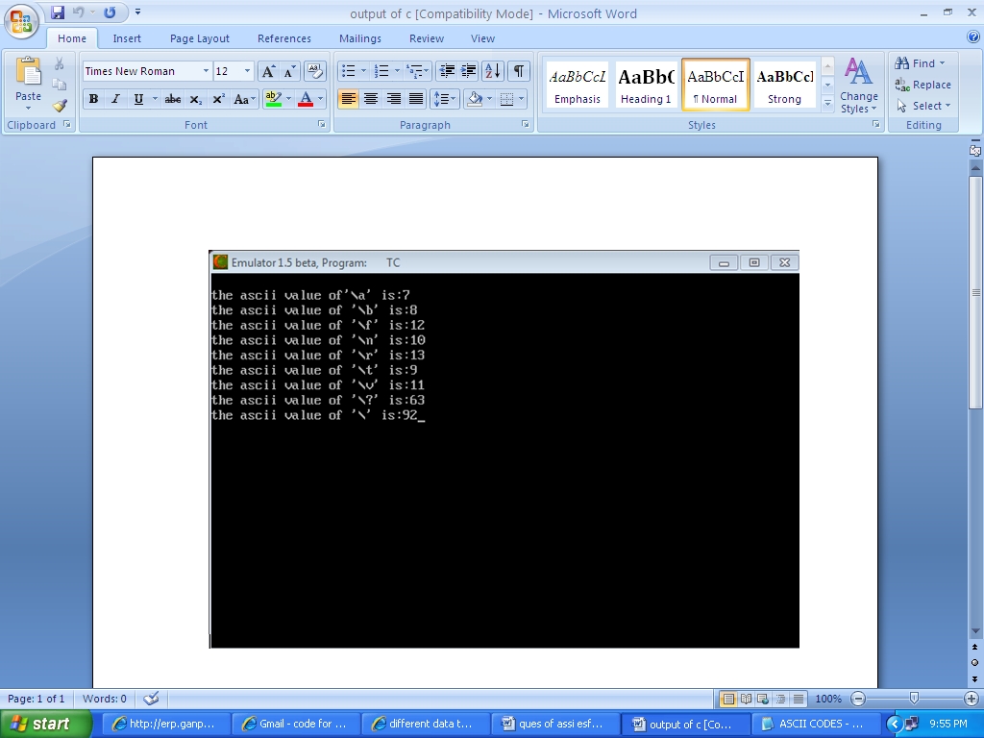

**ANS-2**

The C language provides many basic types. Most of them are formed from one of the four basic arithmetic type specifiers in C (char, int, float and double), and optional specifiers (signed, unsigned, short, long  
)

Char- smallest addressable unit of the machine that can contain basic character set. It is an integer type. Actual type can be either signed or unsigned depending on the implementation

signed char- same size as char, but guaranteed to be signed

unsigned char- same size as char, but guaranteed to be unsigned.

short  
short int  
signed short  
signed short int- *short* signed integer type. At least 16 bits in size

unsigned short  
unsigned short int- same as short, but unsigned

int  
signed int- basic signed integer type. At least 16 bits in size

unsigned  
unsigned int- same as int, but unsigned

float-can be used when valuws are in decimals.

ANS-3

The C language provides many basic types. Most of them are formed from one of the four basic arithmetic type specifiers in C (char, int, float and double), and optional specifiers (signed, unsigned, short, long

TOKENS -KEYWORDS

-CONSTANTS

-INDENTIFIER

-STRING

-SPECIAL SYMBOL

-OPERATERS

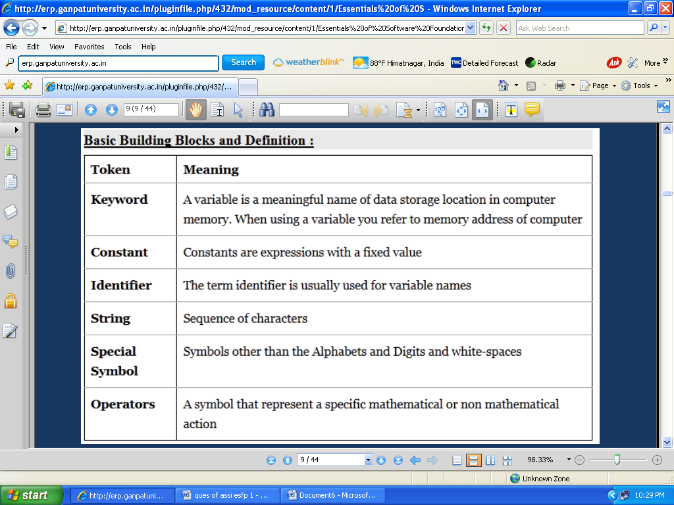

**ANS-4**

BACKSLASH CHARACTERS

THERE ARE SOME CHARACTERS WHICH HAS MEANING IN C LANGUAGE

THEY SHOULD BE PRECEDED BY BACKSLASH SYMBOL TO MAKE USE OF SPECIAL FUNCTION OF THEM

